EXPLORING CAN FOR REAL TIME APPLICATIONS
AIM:
The main aim of this project is to display the engine temperature, reverse alert and control the door glass windows using CAN protocol.

INSIGHT:
- Knowledge of Embedded-C programming
- Thorough with the LPC2129 Architecture, General purpose I/O Interface, ADC, Interrupts & CAN interface
- Understanding of CAN protocol

BLOCK DIAGRAM:

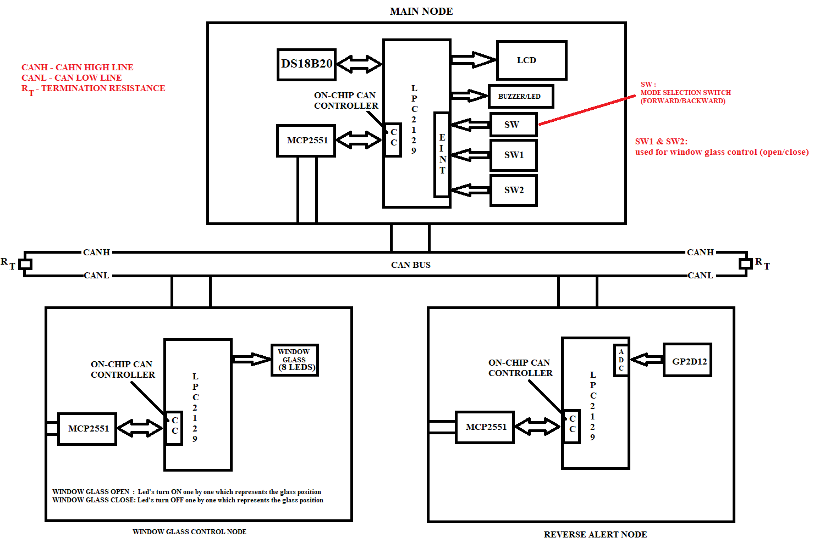

HARDWRAE REQUIREMENTS:

- LPC 2129
- CAN Transceiver (MCP2551)
- LEDS
- LCD
- GP2D12
- SWITCHES
- DS18B20 Temperature Sensor
- USB to UART Converter

SOFTWARE REQUIREMENTS:

- EMBEDDED C – PROGRAMMING
- KEIL-C COMPILER
- FLASH MAGIC

SEQUENCE TO BE FOLLOWED FOR IMPLEMENTATION:
- Create New Folder in your server/laptop/PC and save that folder with your project name
- Individually can check each and every module.
- First check lcd to display character constant, string constant and integer constant.
- Next check the on-chip ADC by connecting variable voltage (from potentiometer) and display input value on LCD.
- Then develop logic for reading the GP2D12 sensor (distance between object and vehicle) information and display it (distance between object and sensor) on LCD.
- Then check the interrupts code. Based on number of time interrupt is raised need to increase the count value and that should be displayed on LCD. (refer LMS for single & multiple interrupts sample codes)
- Then develop logic for reading the temperature sensor (Engine temperature) information and display it (engine temperature) on LCD. (refer LMS for DS18B20 sample code)
- Then download the CAN basic code from LMS and test it on hardware and analyse the working of that code.
- Then check the external interrupt by writing simple code. (refer the sample code in LMS)
- Once all the above modules are checked then start preparing the main code for each node.
- MAIN NODE: Read the temperature information and display it on LCD. And based on switch (SW1/SW2) press count, send one specific value to the window glass control NODE. And one more task of this main node is receiving the reverse control node information and give the indication based on the value received by reverse control node if reverse mode is selected based on switch (SW) press status.
Note: SW, SW1, SW2 need to access with the help of external interrupts.
- WINDOW GLASS CONTROL NODE: Continuously waiting for the data from the main NODE using CAN. If any data is received from main NODE based on that it is controlling the door glass window connected to microcontroller. (Note: instead of motor need to show result on 8 leds by using no.of leds ON based on the value received from main node.). based on the count received need to turn on the led’s.
- REVERSE ALERT NODE: Continuously reading the GP2D12 information and set one limit value to the sensor reading. If the sensor value is below the limit value sends logic 1 to the main node using CAN protocol. Or if the sensor value is greater than the limit value then sends the logic 0 to the main node using CAN protocol.
- If you’re getting this output then your project is completed.

************************** ALL THE BEST ***************************

